

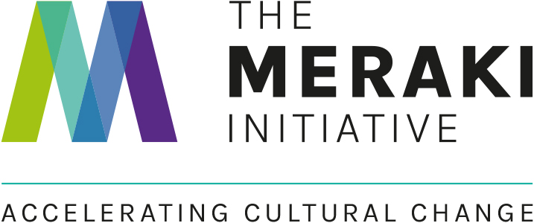

MERAKI EMS GRANT APPLICATION FORM

To support vets of tomorrow with the cost of completing clinical EMS, Meraki is giving away a £70 and £30 EMS grant every month for 12 months from 1st July 2024. To apply send us a cool or fun picture of you on placement interacting and engaging with the team along with this completed form. See full EMS grant application details, eligibility criteria and T&Cs.

Your photo
50-100 word caption to describe and give context to your picture
Names + job role of others in picture
Your details
Name
Vet school and year of study
Instagram handle
Placement details
Workplace name
Workplace address
Placement date
Placement length
Placement type
What would you use the money for if you won?
Strength in diversity (optional)
Underrepresented group
Anything the workplace did to create an inclusive culture

Applicants must be a registered member of Meraki. Register here.
Send in your photo and application form or any questions about the application process to olly@merakiinitiative.com. Deadline 23.59 on the last day of each month. Privacy Policy.

